UNIT-4 INTERACTIVE MARKETING
MEANING OF INTERACTIVE MARKETING
Interactive marketing is a one-to-one marketing practice that centres on individual customer and prospects’ actions. Interactive marketing involves marketing initiatives that are triggered by customers’ behaviours and preferences; for this reason, it is a major shift from traditional campaign-based marketing efforts. A customer-centric strategy, interactive marketing involves reacting to customer actions and striving to meet their expectations and demands.

TYPES OF INTERACTIVE MARKETING
Interactive marketing includes many types of initiatives. Marketers may interact with customers via dynamic content such as visual storytelling, personalized content, layered information, and two-way interaction. No matter which type of interactive marketing initiative you implement, the goal is to make content engaging and relevant for customers.
- Interactive Storytelling – Marketers can seize opportunities to be as dynamic with content as possible; this may mean adding an animation or infographic to a blog post or creating native ads rooted in storytelling that incorporated mixed media elements. Break up long-form posts and advanced landing pages with text divisions, video and audio clips, and interactive components that allow sharing and discovering more information.
- Personalized Content – Use advanced technology to gain insights into customers’ demographics, geographic data, lifecycle information, and more to deliver personalized, relevant content and offers. When you know as much as you can about your customers as individuals, you can create the most meaningful experiences for them. Customers will relate to the content more fully when it is personalized appropriately, and they will be more apt to interact with the content by sharing it.
- Layered Information – Educating customers has become a top priority for marketers, and interactive marketing is a smart way to layer in information for consumers by delivering detailed content in increments. Marketers have the ability to tell brand stories by providing snippets of information in easy-to-read quick takes and then delivering more detailed, informative content in other layers to audience members who want to know as much about a topic as possible.
- Two-Way Interaction – Two-way interaction initiatives are at the heart of interactive marketing because they give consumers a vehicle for active participation. For example,

interactive tools such as quizzes, calculators, branching content, games, and interactive videos provide a more powerful experience for the audience.

CONCEPT AND OPTIONS OF INTERACTIVE MARKETING:
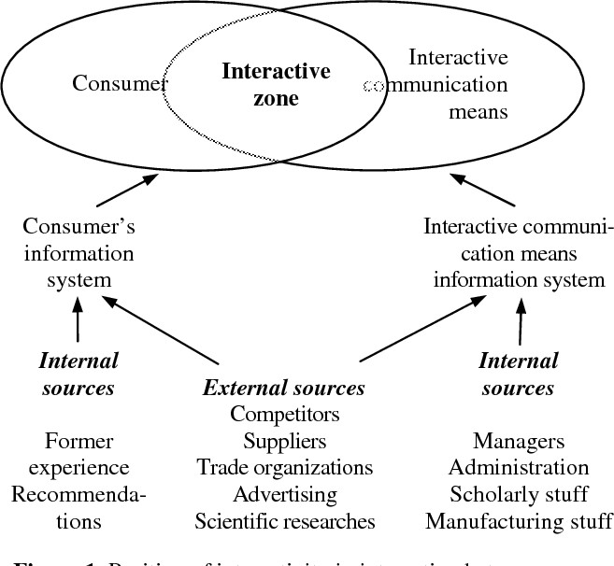
It's a two-way approach to marketing that focuses on interaction and collaboration. Instead of simply talking at your customers with a one-way stream of marketing, an interactive approach makes it a group activity.

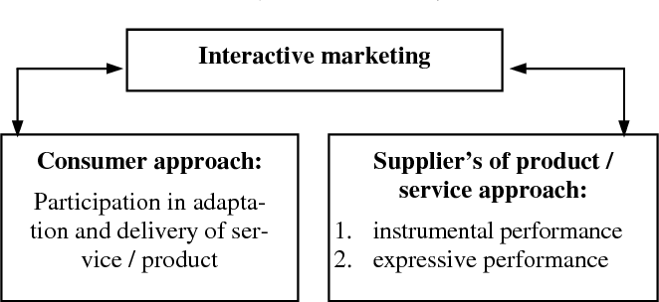

SOCIAL MEDIA MARKETING MEANING:
The term social media marketing (SMM) refers to the use of social media and social networks to market a company’s products and services. Social media marketing provides companies with a way to engage with existing customers and reach new ones while allowing them to promote their desired culture, mission, or tone. Social media marketing has purpose- built data analytics tools that allow marketers to track the success of their efforts.

FIVE KEY PILLARS OF SOCIAL MEDIA MARKETING
According to Buffer, there are five key pillars of social media marketing:

- Strategy: This step involves determining goals, the social media channels to be used, and the type of content that will be shared.
- Planning and Publishing: Businesses should draft plans of what their content will look like (i.e., will there be videos? Photos? How much script?) and decide when it will be put out on the platform.
- Listening and Engagement: Monitoring what users, customers, and others are saying about the posts, brands, and any other business assets. This may require the adoption of a social media engagement tool.
- Analytics and Reporting: Part of being on social media is knowing how far posts are going, so reports of engagement and reach are very important
- Advertising: Purchasing ads on social media is a great way to promote and further develop a brand.

SOCIAL MEDIA CONCEPT
The term social media refers to a computer-based technology that facilitates the sharing of ideas, thoughts, and information through virtual networks and communities. Social media is internet-based and gives users quick electronic communication of content, such as personal information, documents, videos, and photos. Users engage with social media via a computer, tablet, or smartphone via web-based software or applications. While social media is ubiquitous in America and Europe, Asian countries like Indonesia lead the list of social media usage. More than 4.5 billion people use social media, as of October 2021.

- Social media is a computer-based technology that facilitates the sharing of ideas, thoughts, and information through the building of virtual networks and communities.
- There are more than 4.5 billion social media users around the world.

- The largest social media networks include Facebook, Instagram, Twitter, YouTube, and TikTok.
- Social media typically features user-generated content and personalized profiles.
- By 2023, the number of social media users in the United States is forecast to increase to approximately 257 million.

SOCIAL MEDIA TOOLS

- Biteable. Creating content for social media is an essential part of the game.
- Buffer. Buffer started off as a scheduling tool for Twitter.
- Buzzsumo. Research is a crucial part of marketing.
- Missinglttr.
- MeetEdgar.
- Hootsuite.
- Mention.
- Sumo

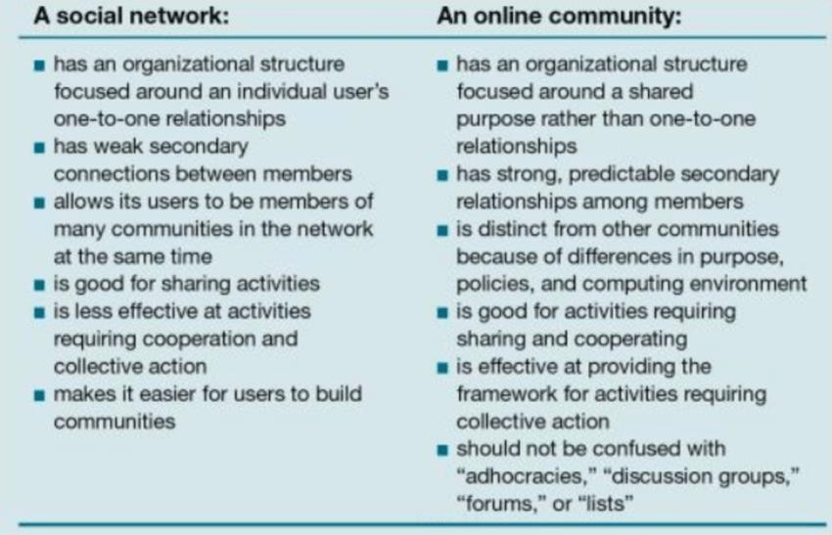
ONLINE COMMUNITIES AND SOCIAL NETWORKS:

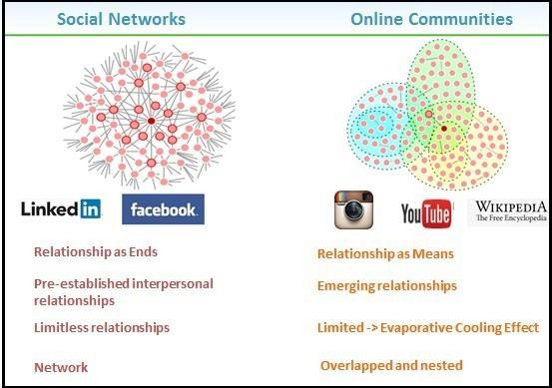

Highlights:

Social Networks
  - Bound together by pre-established interpersonal connections
  - Each connection has his or her own social network
  - Characterized by a spider web-like "network" structure

Online Communities
- Bound together by a common interest or topic
- ANY person can be a part of ANY community
- Characterized by a more complex overlapping and "nested" structure.

Online and social community marketing is about using the power of online communities to:

- Build personal relationships and networks of trust.

- Bring together people with common interests or profiles.

- Engage these specific groups of people.
Depending on the goals you want to serve and the target groups you want to engage, there are different types of online communities. The outcomes we strive for when engaging a community

aim to fulfil several marketing and business objectives. Depending on these objectives, online communities will require more or less resources, dedication and value.

BLOGGING
Meaning of Blogging: Blog Marketing is a content marketing strategy. The marketing strategy uses blogs to address potential customers directly and individually, thus achieving customer loyalty for their own brand. This type of marketing uses viral marketing methods in which an interest group is built based on a blog.
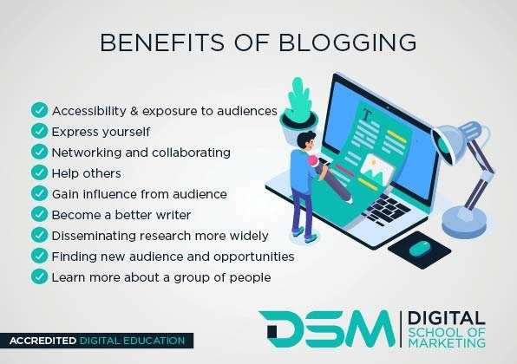

TYPES OF BLOGS TO CREATE:

  - Food blogs
  - Travel blogs
  - Health and fitness blogs
  - Lifestyle blogs
  - Fashion and beauty blogs
  - Photography blogs
  - Personal blogs
  - DIY craft blogs
  - Parenting blogs
  - Music blogs
  - Business blogs
  - Art and design blogs
  - Book and writing blogs

  - Personal finance blogs
  - Interior design blogs
  - Sports blogs
  - News blogs
  - Movie blogs
  - Religion blogs
  - Political blogs

ROLE OF BLOGGING
The purpose of a blog is to provide content on your website that answers your prospective customers' questions and helps them learn about your product or service. It expands your brand's visibility by giving Google and other search engines content to index and serve up in search results.10-Dec-2020

VIDEO MARKETING
Meaning of Video Marketing: Video marketing means using videos for promoting and telling people about your product or service. It helps increase engagement on your digital and social channels, educates your audience, and allows you to reach them with a new medium TOOLS & TECHNIQUES:
- VidIQ.
- TubeBuddy.
- VEED.
- Agorapulse.
- Vidyard.
- Animoto.
- Common Craft.
- Filmora.

MOBILE MARKETING TOOLS & TECHNIQUES:
Meaning of Mobile Marketing
Mobile marketing is any advertising activity that promotes products and services via mobile devices, such as tablets and smartphones. It makes use of features of modern mobile technology, including location services, to tailor marketing campaigns based on an individual's location.

Mobile marketing is a way in which technology can be used to create personalized promotion of goods or services to a user who is constantly connected to a network.

MOBILE MARKETING TOOLS:
- Buffer. Buffer is an app made for social media management for various accounts.
- AdMob by Google. AdMob is an app made by Google for in-app advertising.
- Boostfy.
- GetResponse.
- SEMRush.
- SlickText.
- Localytics.
- Kiip.

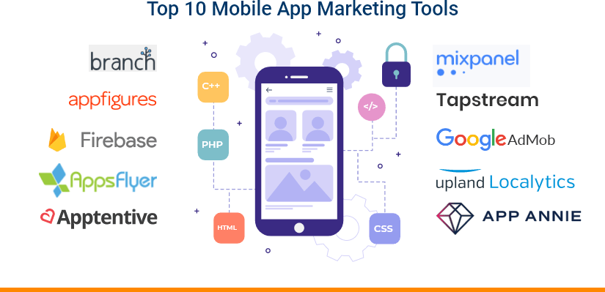

PPC MARKETING:
Meaning: PPC or pay-per-click is a type of internet marketing which involves advertisers paying a fee each time one of their ads is clicked. Simply, you only pay for advertising if your ad is actually clicked on. It’s essentially a method of ‘buying’ visits to your site, in addition to driving website visits organically.

THE BENEFITS OF USING PPC

PPC has many advantages that will benefit your business, including the following:

- Optimised PPC is cost effective
- Your ad will be displayed on the first results page when someone searches for a related term
- More exposure and brand visibility as targeted traffic is directed to your site
- You can run multiple ad campaigns for each keyword
- It results in higher click-through rates (CTR), more conversions, and increased sales revenue
- Provides instant traffic

